**Lab practical 10**

**COA**

**1.(a) Write a program in assembly language to print the numbers from 0 to 9.**

**Code:**

**ORG 100H**

**MOV CX,10**

**MOV AL,'0'**

**PRINT_LOOP:**

**MOV DL,AL**

**MOV AH, 2**

**INT 21H**

**INC AL**

**LOOP PRINT_LOOP**

**MOV AH,4CH**

**INT 21H**

**OUTPUT:**

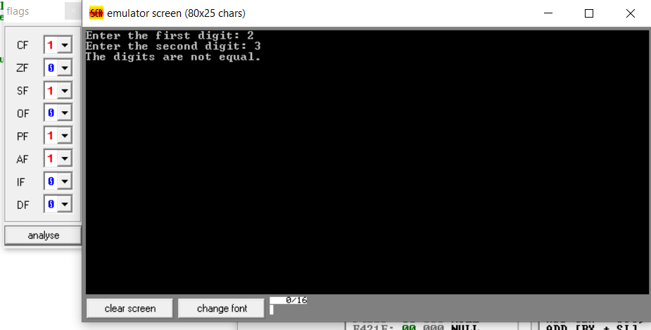

**(b) Write an assembly language program to print the characters from A to Z in reverse order.**

**CODE:**

**ORG 100H**

**MOV CX,26**

**MOV AL,'Z'**

**PRINT_LOOP:**

**MOV DL,AL**

**MOV AH, 2**

**INT 21H**

**DEC AL**

**LOOP PRINT_LOOP**

**MOV AH,4CH**

**INT 21H**

**OUTPUT:**

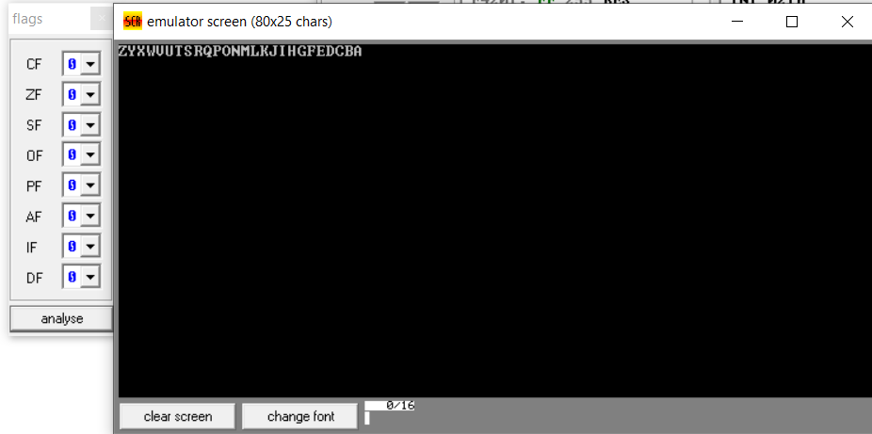

**2. (a) Write a program in assembly language to print the numbers from 0 to 9 in reverse order.**

**CODE:**

**ORG 100H**

**MOV CX,10**

**MOV AL,'9'**

**PRINT_LOOP:**

**MOV DL,AL**

**MOV AH, 2**

**INT 21H**

**DEC AL**

**LOOP PRINT_LOOP**

**MOV AH,4CH**

**INT 21H**

**OUTPUT:**

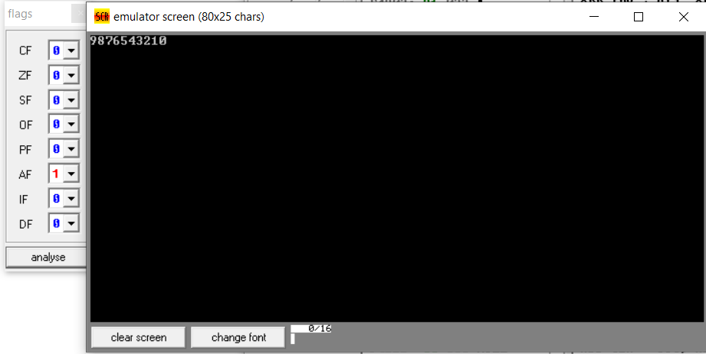

**(b) Write an assembly language program to print the characters from A to Z.**

**CODE:**

**ORG 100H**

**MOV CX,26**

**MOV AL,'A'**

**PRINT_LOOP:**

**MOV DL,AL**

**MOV AH, 2**

**INT 21H**

**INC AL**

**LOOP PRINT_LOOP**

**MOV AH,4CH**

**INT 21H**

**OUTPUT:**

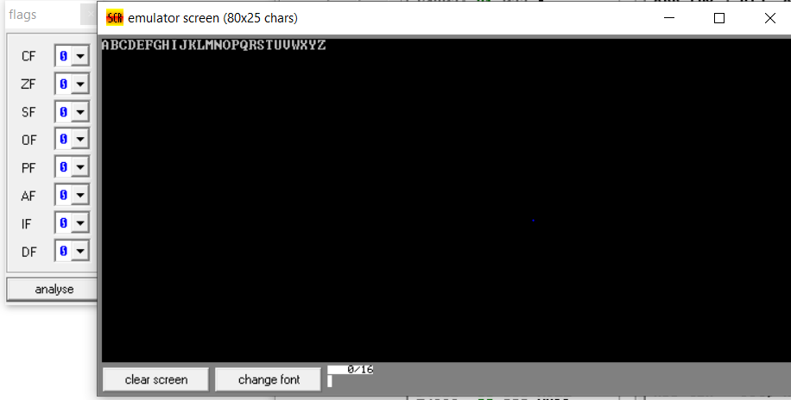

**GITHUB:**

[**https://github.com/srijachakilam15/COA/blob/main/lab%20practical%2003.docx**](https://github.com/srijachakilam15/COA/blob/main/lab%20practical%2003.docx)